MARK ABEL
composer

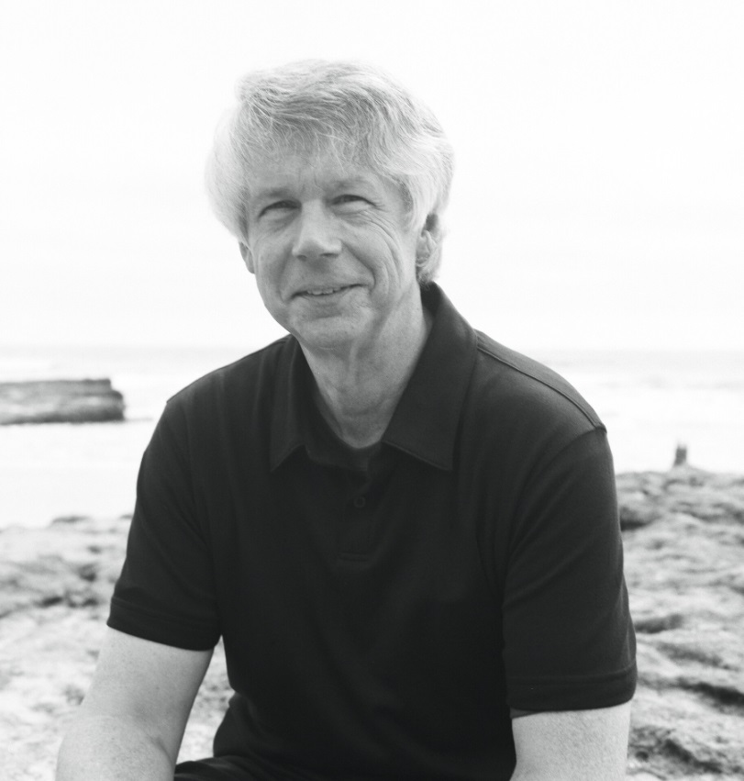
Mark Abel’s idiom eludes easy pigeon-holing. He primarily writes vocal music, whose contours extend from art song to larger forms involving the orchestra to a 103-minute chamber opera. While possessing a strong gift for melody grounded in an individual harmonic language, Abel is also a lyricist of considerable emotional power. This often lends to his music the sense of encountering a more complete persona than that of composers who set texts written by others. Abel’s style follows a consistent path in its attempts to directly engage listeners and be taken at face value while leaving something deeper to ponder later.

Abel (b. 1948) has been based in California for the past three decades, logging lengthy stays in the Bay Area, the Central Coast and Southern California. A Baby Boomer who was deeply affected by the tumult of the 1960s, he dropped out of college at 20. He spent a dozen years on the treadmill of New York City’s rock-and-roll scene before rediscovering classical and changing his musical direction during a long period of working as a journalist in San Francisco. A maverick figure, Abel has over time developed an unusual, sturdily constructed hybrid of classical, rock and jazz, constantly working toward new and more refined expressions of that synthesis. Critics have praised his melding of these disparate elements as one of the very few successful experiments along such lines.

Abel’s music has begun to circulate more widely since he became affiliated with the Delos label in 2012. The first two recordings for Delos were “Terrain of the Heart,” a collection of three song cycles for soprano and piano, and “The Dream Gallery,” a seven-movement cycle for soloists and chamber orchestra that movingly depicts the lives of archetypal Californians from all walks of life. The material on “Terrain of the Heart” was hailed as "art song at a high-water mark of invention” and “The Dream Gallery” attracted notices such as “profound and compelling.”

In March 2016 Delos released the double CD “Home Is a Harbor,” pairing Abel’s first opera (of the same name), and The Palm Trees Are Restless, a song cycle setting poems of Kate Gale and featuring Grammy-winning soprano Hila Plitmann.

Two years later, Delos has issued “Time and Distance,” a powerful collection of vocal works comprised of three pieces sung by Plitmann and two by West Coast mezzo soprano Janelle DeStefano. The pianists are Tali Tadmor and Carol Rosenberger. The texts are by Gale, Abel and California poet Joanne Regenhardt.

One of the album’s tracks, a Gale setting entitled Those Who Loved Medusa, is a stark and gripping recasting of the mythological story, closely matched by Abel’s multi-hued palette of musical textures. The piece seems to resonate uncannily with the spate of contemporary news stories exposing the persistence of sexual harassment. Its journey also dovetails with this Abel credo: “I’m trying to write interesting music, but it must express emotion. Without that, it doesn’t mean much to me.”

Abel has recently begun working in the chamber idiom for the first time. His Trio for Clarinet, Cello and Piano will be given in July 2018 at the Chamber Music Northwest festival in Portland, Oregon.

***************************************

MARK ABEL
principal works

Trio for Clarinet, Cello and Piano (2017) – to be premiered by David Shifrin at Chamber Music Northwest, July 2018

“Those Who Loved Medusa” (2017) – concert aria (appears on the Delos CD “Time and Distance”)

“The Invocation” (2017) – solo song for mezzo soprano and piano (appears on the Delos CD “Time and Distance”)

“The Ocean of Forgiveness: Five Poems of Joanne Regenhardt” (2016) – cycle for mezzo soprano and piano (appears on the Delos CD “Time and Distance”)

“In the Rear View Mirror, Now” (2016) – cycle for soprano, piano and organ (appears on the Delos CD “Time and Distance”)

“Home Is a Harbor” (2014/2015) – chamber opera in three acts (appears on the Delos CD “Home Is a Harbor”)
“The Palm Trees Are Restless: Five Poems of Kate Gale” (2014) -- cycle for soprano and piano (appears on the Delos CD “Home Is a Harbor”)
“The Benediction” (2012) – solo song for tenor/or soprano and piano (recorded by Hila Plitmann on the Delos CD “Time and Distance” and by Kyle Bielfield on the Delos CD "Stopping By")
“Rainbow Songs” (2011/2012) -- cycle for soprano and piano (appears on the Delos CD “Terrain of the Heart”)
“The Dream Gallery: Seven California Portraits” (2009/2010) -- song cycle for seven soloists and chamber orchestra (appears on the Delos CD of the same name)
“Gentle Spirit” (2008) -- tone poem for orchestra
“The Dark-Eyed Chameleon” (2007) -- song cycle for soprano and piano (appears on the Delos CD “Terrain of the Heart”)
“The True Believers” (2006) -- drama in three movements for soprano, baritone and orchestra
“Mystic Brave Bird” (2005) -- elegy for mezzo soprano and orchestra
“Five Poems of Rainer Maria Rilke” (2004) -- song cycle for soprano and piano (appears on the Delos CD “Terrain of the Heart”)
“One Long Peace” (2003) -- elegy for soprano and orchestra
“The Girl Made of Wood: Seven Poems of Pablo Neruda” (2001) -- song cycle for soprano and orchestra

markabelmusic.com

